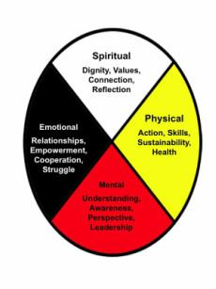
Registration Form
Rhino of Balance – October 19 to 21, 2018

Information Collected on this form will only be used by the men working on the registration team. If you have any questions please contact Alan Hernandez rhinoofbalance@gmail.com or 604 208 0054

Personal Information:
Name: __________________________________ Age _____ Email:_______________________________________
Phone ◻ Cell: ____________________________ ◻ Home: _______________________________________________
Address: _________________________________________________________________________________________
If you have done an initiation weekend, please provide details here: _________________________________________
If you are on a men’s team what is your team’s name? ____________________________________________________
Special Needs (dietary or other)
Health Issues

Emergency Contact Information
Name: _________________________________ Relationship to participant ___________________________________
Phone ◻ Cell: ______________________________ ◻ Home:_______________________________________________
◻ What happens at this event is confidential and will remain between participants only. We only share our own experience and growth and respect the confidences of others
Participant name (printed) |  | Participant Signature |  | Date

Send forms to rhinoofbalance@gmail.com or register online at thorswarriors2018.weebly.com. Send e-transfers to martnukwoolley@gmail.com , password “Rhino”, or cheques to Rhino of Balance ℅ Martyn Wooley, 4752 Joyce Ave, Powell River, BC, V8A 3B6

